1. Go to: <https://www.cftc.gov/MarketReports/CommitmentsofTraders/HistoricalCompressed/index.htm>

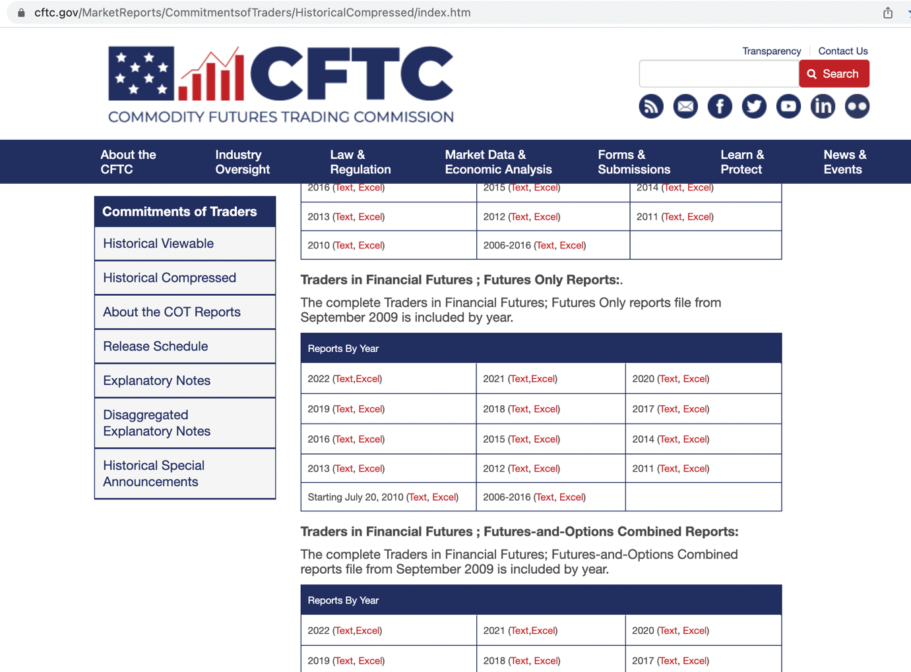

2. Scroll down to ‘Futures Only Reports’

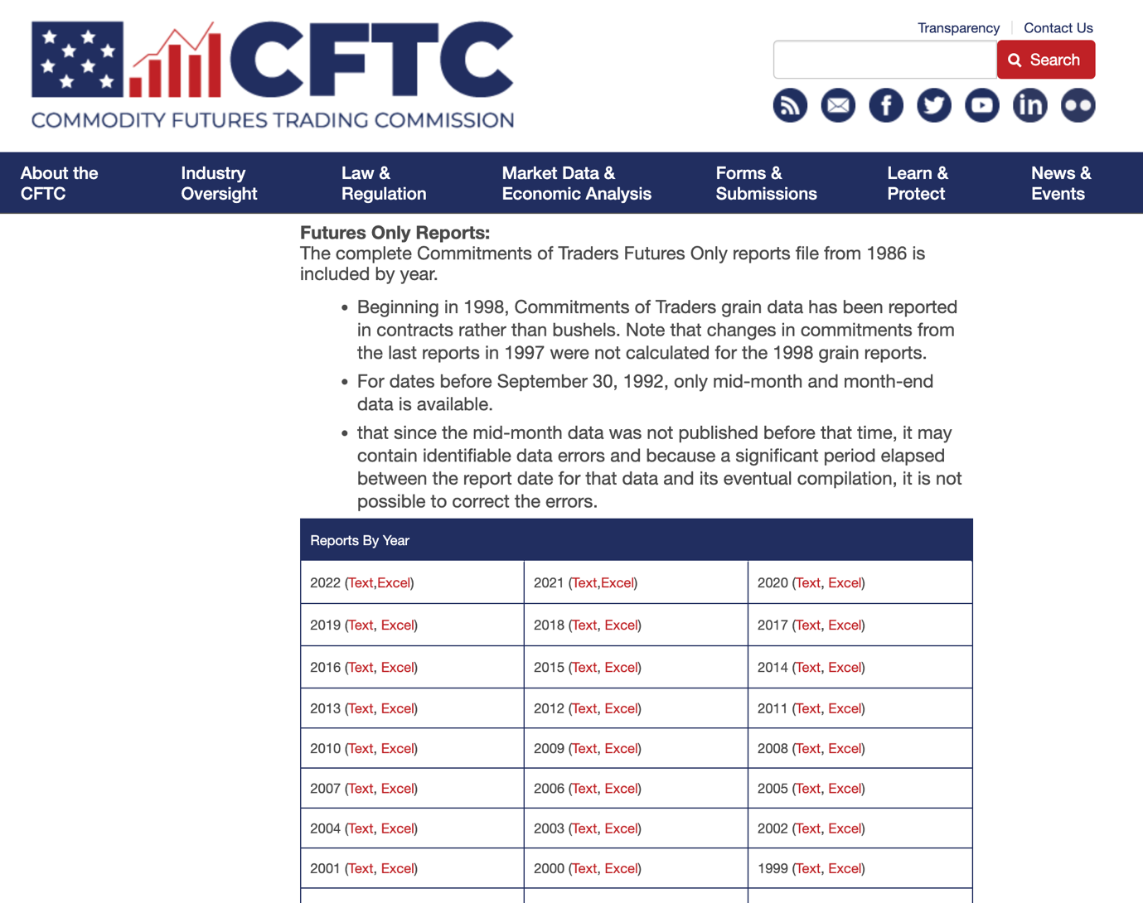

3. Click the link that pertains to the current year, to download ZIP file

4. Unzip file

5. Copy data from excel file

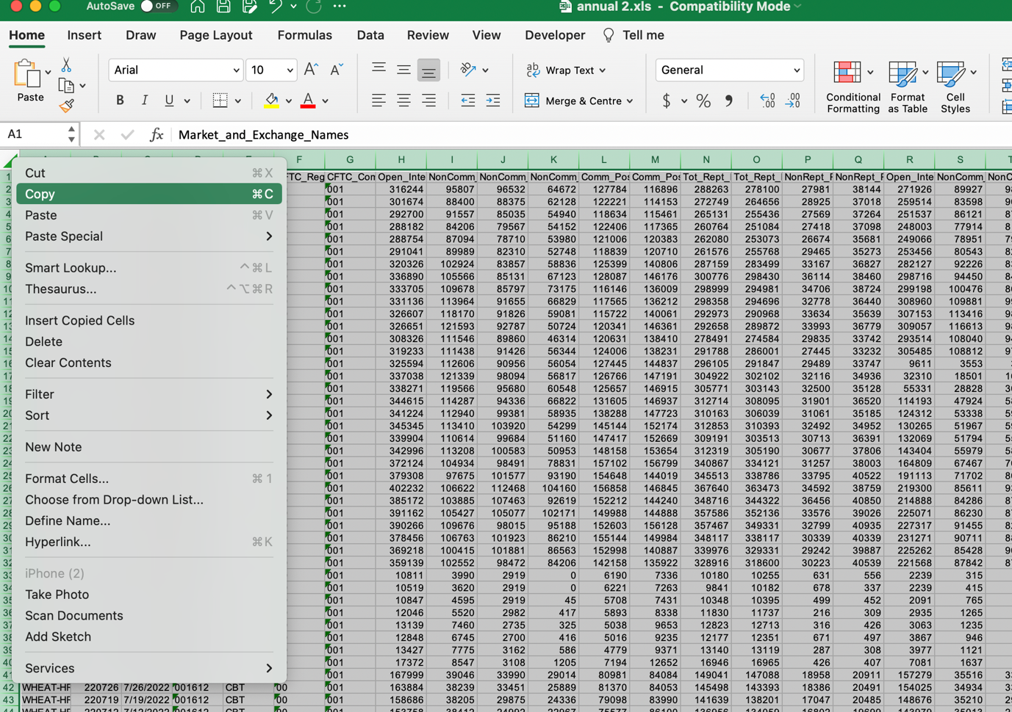

6. Paste into ‘Futures Only Report Raw’ tab in 014_FX_Commitment_of_Traders

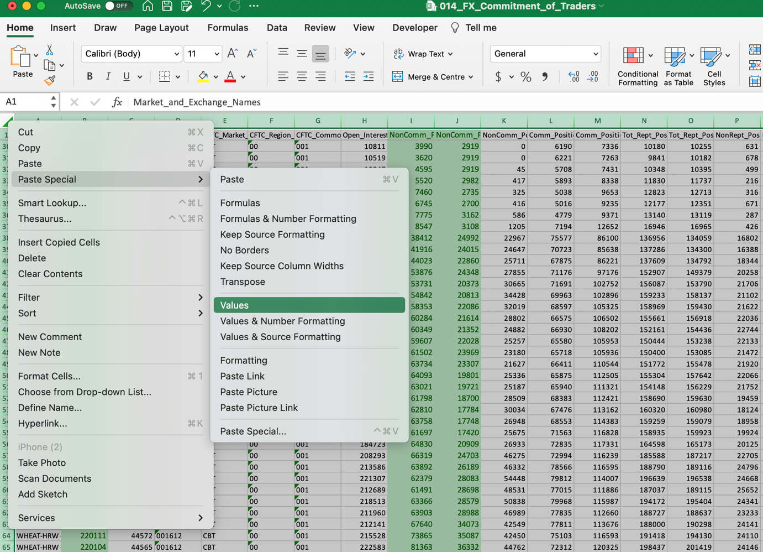

7. Run python script 014_FX_Commitment_of_Traders.py